A Step-By-Step Guide to BirdNET Analyzer

Rebecca Cohen, Irina Tolkova, Meghan Beatty, Spencer Keyser, Isha Bopardikar, Chiti Arvind, V.V. Robin

Adapted and updated from materials previously created by Ashraft Syazwan Ahmady Yusni, Nor Amira Abdul Rahman, Maria Vasilkin, and Dena Clink, and based on: Symes L, Sugai LSMS, Gottesman B, Pitzrick M, Wood C. 2023. Acoustic analysis with BirdNET and (almost) no coding: practical instructions. https://doi.org/10.5281/zenodo.8357176

The data and downloads for this guide can be found here

Part 1: Software Install

1.1 BirdNET Analyzer v.2.4.0
- Download BirdNET Analyzer v2.4.0 installer from the BirdNET GitHub repository releases page
- BirdNET-Analyzer-2.4.0-win_amd64.exe for Windows
- BirdNET-Analyzer-2.4.0-mac_arm64.pkg for MAC

- Double click the downloaded installer file to run it; you may need to tell your computer that it is safe to run. Click More info and Run anyway.

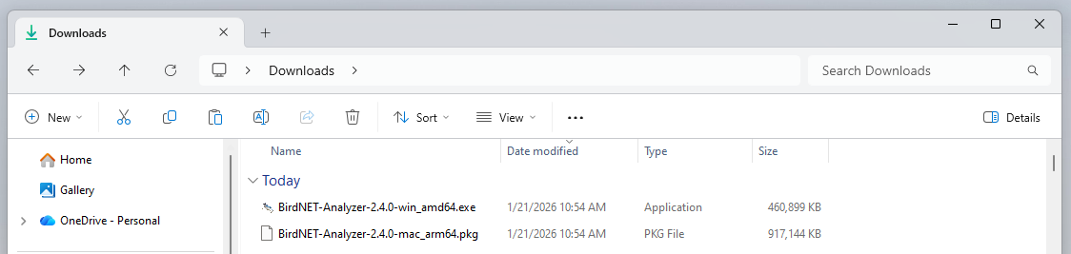
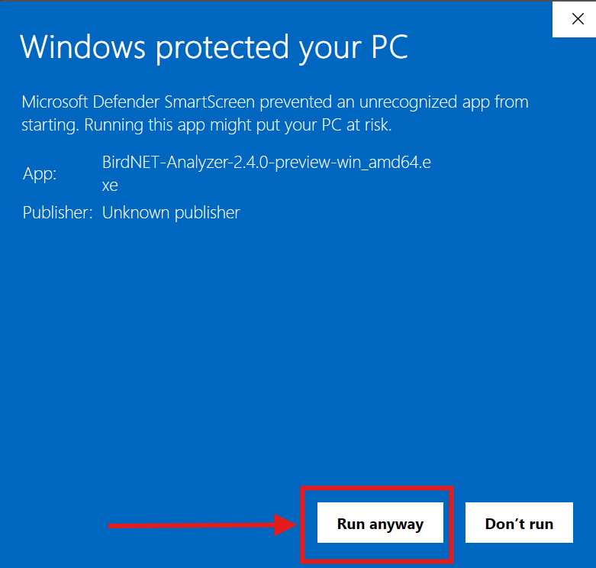
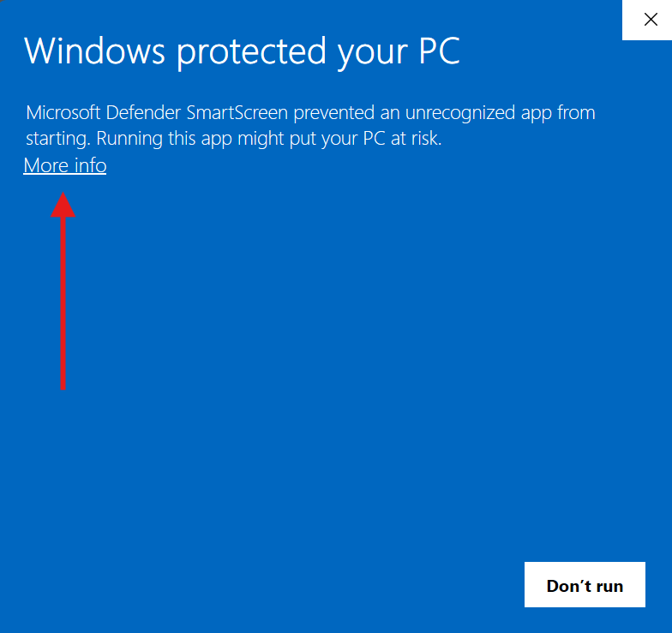

- Accept the license agreement and click Next. Check the box to create a desktop shortcut and click Next. Click Install.

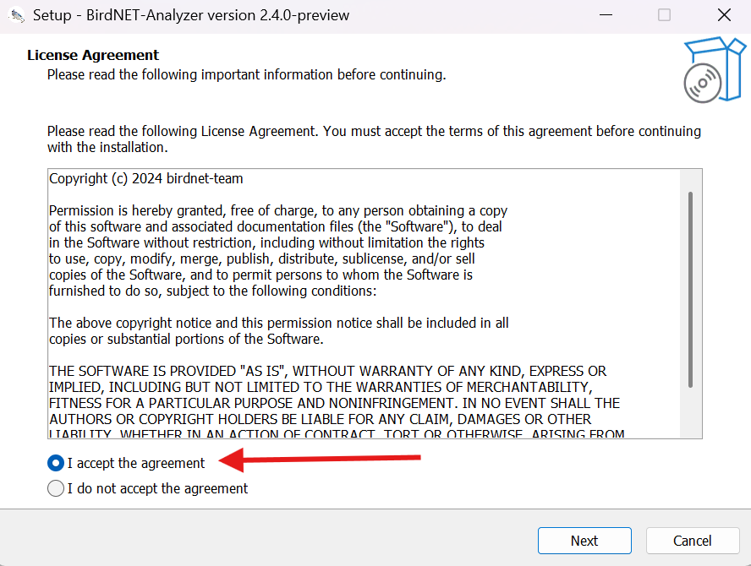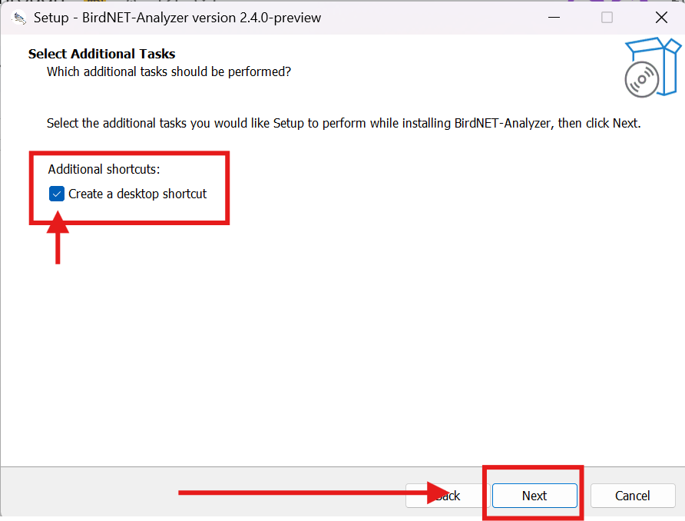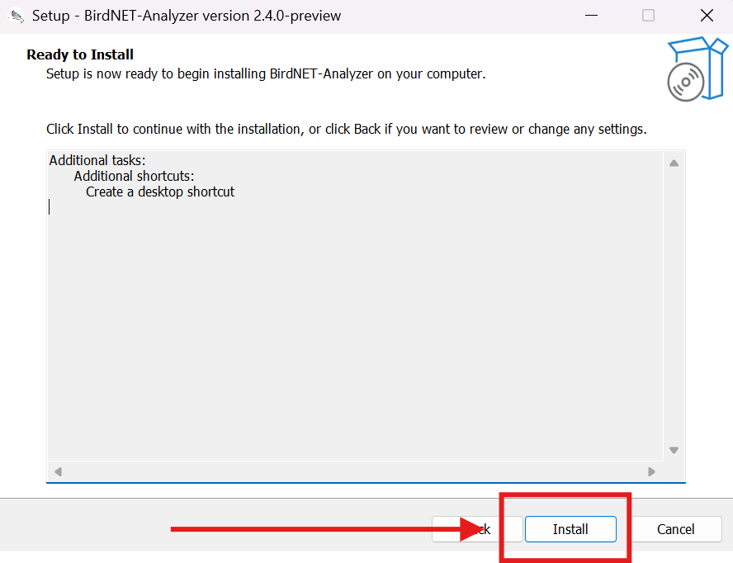

1.2 Raven Annotate Pre-Release Build (install optional)
Raven Annotate is a new Raven Workbench module that is intended to replace Raven Pro’s functionality for visualizing raw audio files, annotating acoustic events, making automatic feature measurements, and more. Raven Annotate is still in development and has not yet been publicly released, but the basic visualization and annotation functionality is up and running in this build. New functionality will continue to be developed and released in coming months. If you have Raven Pro or Raven Lite already installed, it is optional to install Raven Annotate.

- Use one of the following links to download the appropriate Raven Annotate installer, according to your operating system:
  - Windows:https://updates.ravensoundsoftware.com/updates/workbench/raven_annotate/win_x64/Raven-Annotate-1.0.2.exe
  - MacOS:https://updates.ravensoundsoftware.com/updates/workbench/raven_annotate/mac_arm64/Raven-Annotate-1.0.2.dmg
  - Linux:https://updates.ravensoundsoftware.com/updates/workbench/raven_annotate/linux_x64/raven-annotate_1.0.2-1_amd64.deb

- Locate the installer in your Downloads folder and double click to run.
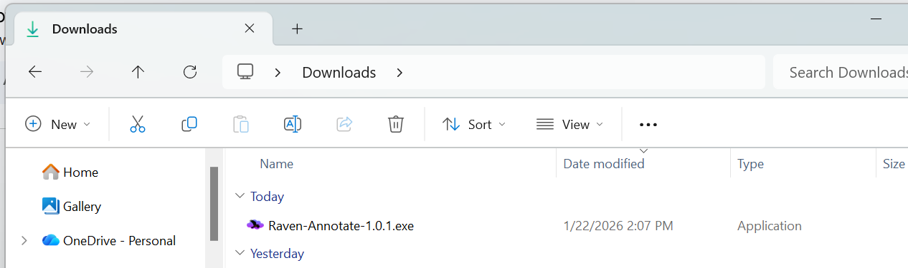

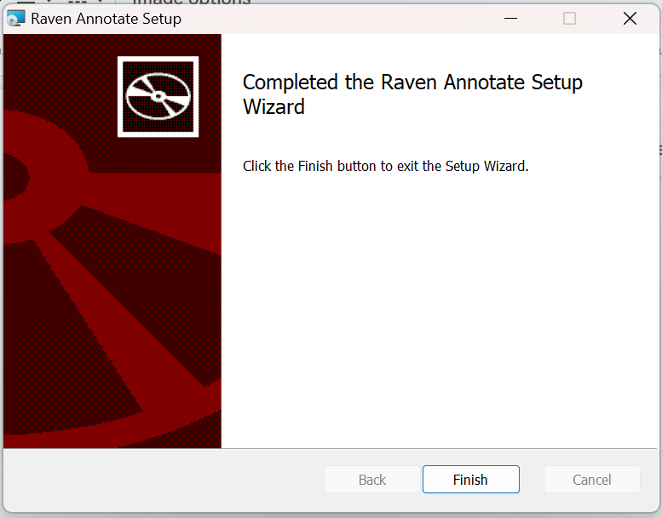
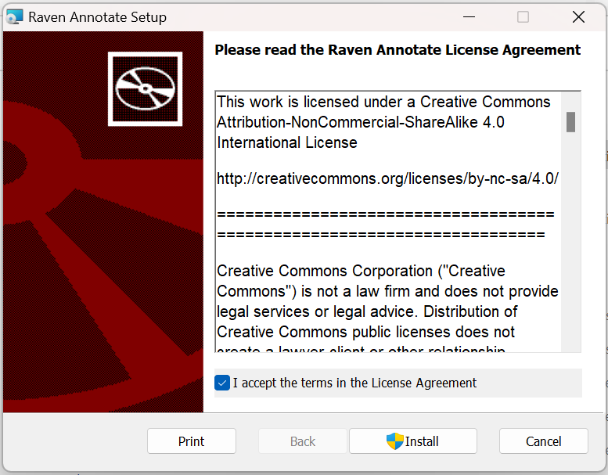
- Follow the prompts to complete installation by accepting the license agreement and clicking Install.

Part 2: Detecting with BirdNET Model V2.4

2.1 Download workshop materials
- From the GitHub page, download workshop repository “IISER_YC_AdvancedBioacoustics” as a zip file. This repository contains all of the data and code we will be using for the modules we’ll cover this week. Slide decks will be added at the end of the workshop.
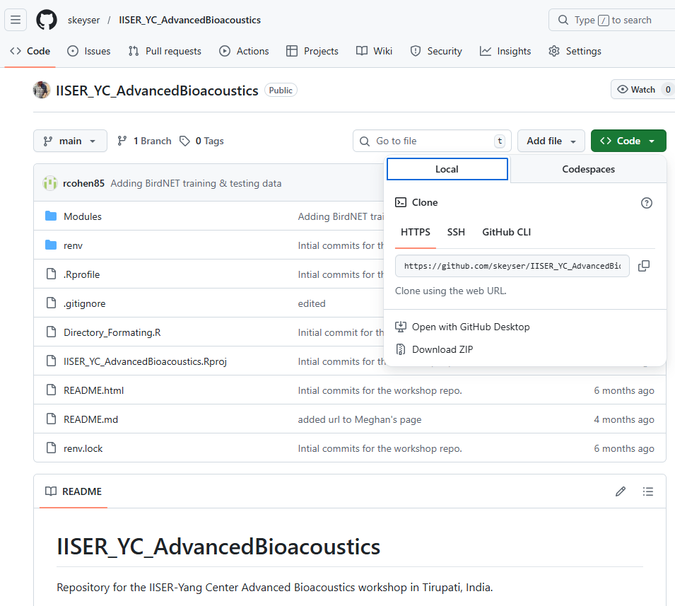

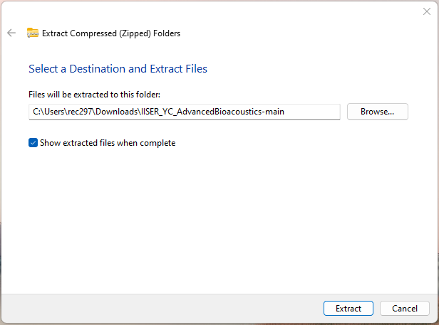
- Unzip the folder and store it in a convenient location on your computer.

2.2 Running BirdNET Analyzer on Bird Data
- From your Desktop, double-click the BirdNET icon to launch BirdNET-Analyzer. It may take a minute for the program to open.
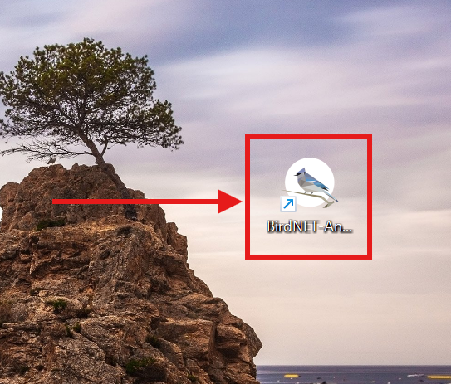

- Navigate to the Batch analysis tab.
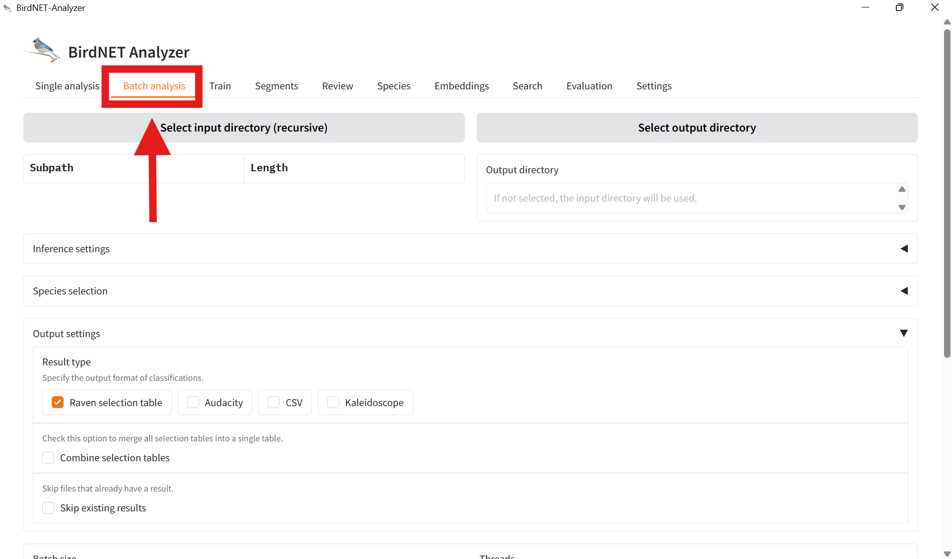

- Click Select input directory and navigate to IISER_YC_AdvancedBioacoustics >> Modules >> DetClass_ML >> Data >> Testing >> Audio Files >> Terrestrial.

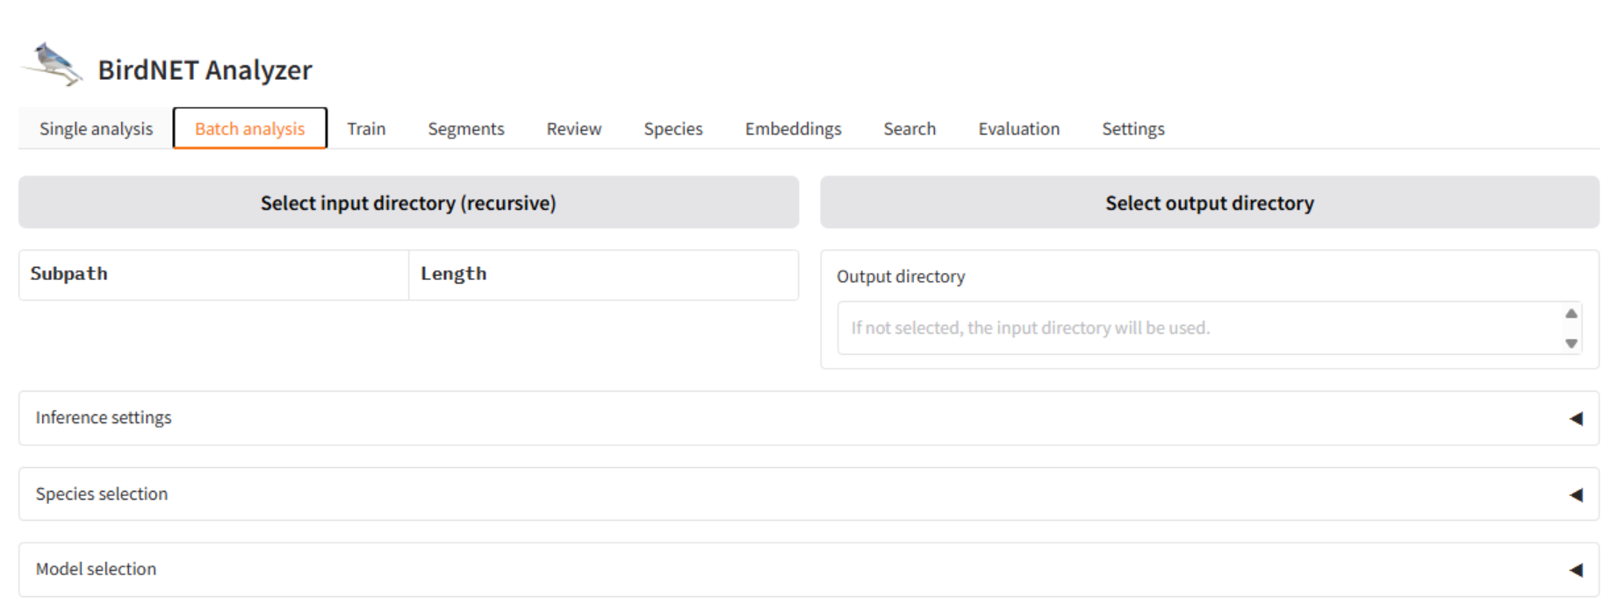
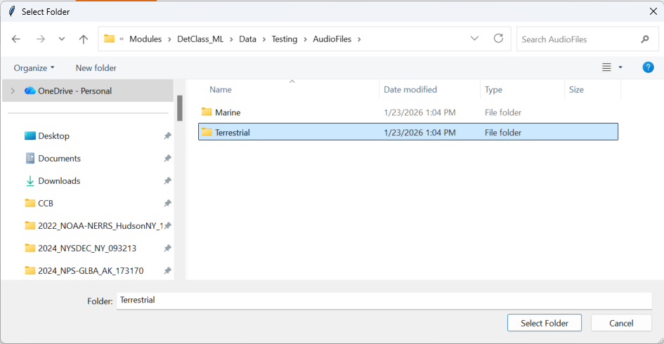

- Click Select output directory and navigate to IISER_YC_AdvancedBioacoustics >> Modules >> DetClass_ML >> Data >> DefaultModel >> Terrestrial >> Predictions.
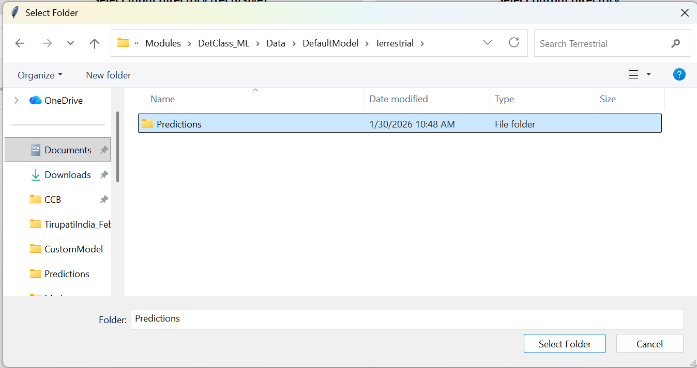
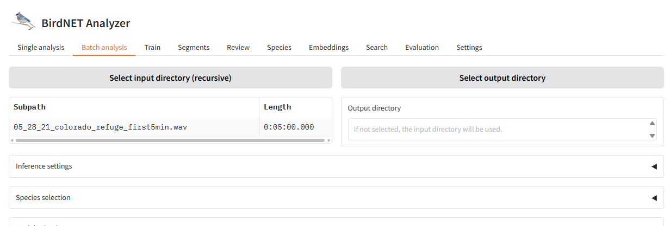

- At the bottom of the screen, click Analyze. A progress bar will appear. When the analysis is complete it will switch to the message “All files analyzed!” Navigate to IISER_YC_AdvancedBioacoustics >> Modules >> DetClass_ML >> Data >> DefaultModel >> Terrestrial >> Predictions to see the output selection table.
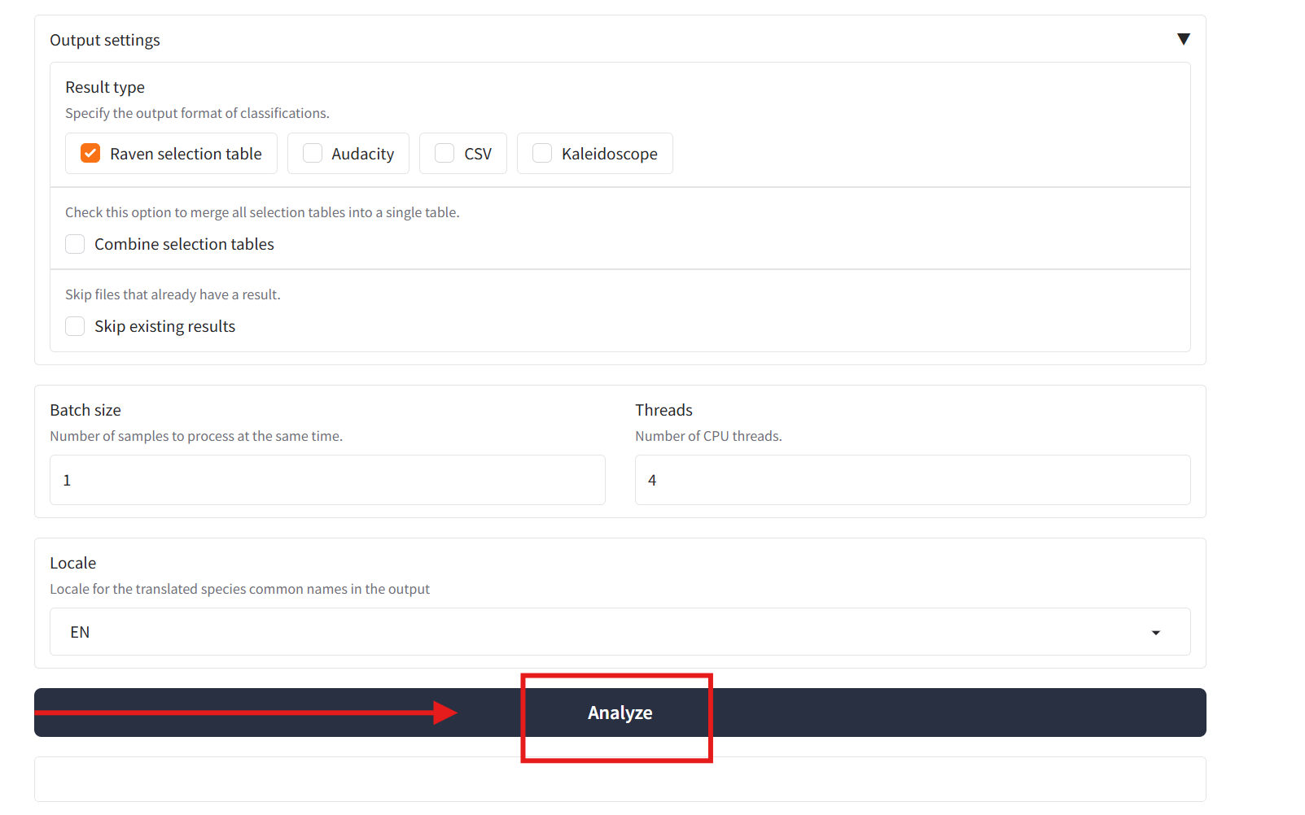
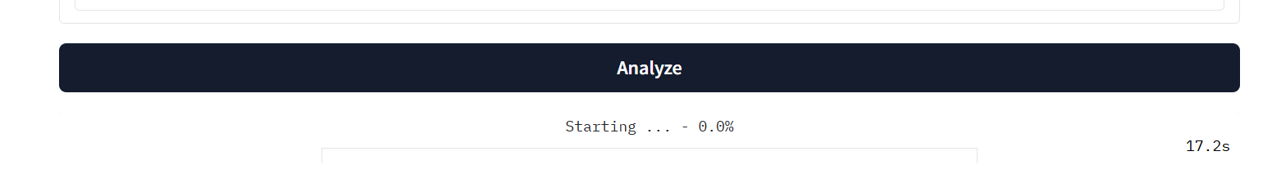

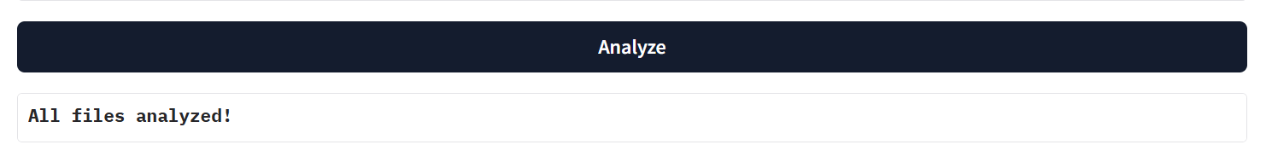

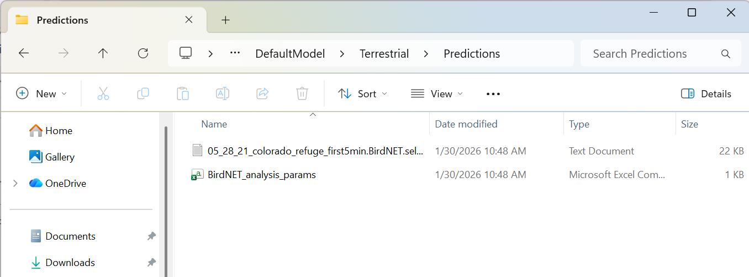

2.3 Running BirdNET Analyzer on Other Data

- In the Batch analysis tab, click Select input directory and navigate to IISER_YC_AdvancedBioacoustics >> Modules >> DetClass_ML >> Data >> Testing >> Audio Files >> Marine.


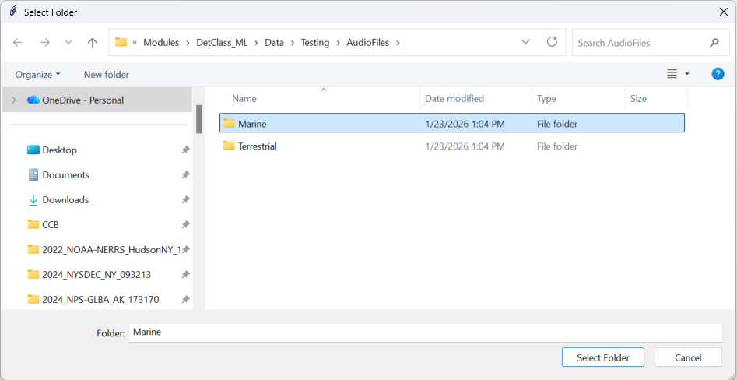

- Click Select output directory and navigate to IISER_YC_AdvancedBioacoustics >> Modules >> DetClass_ML >> Data >> DefaultModel >> Marine >> Predictions.
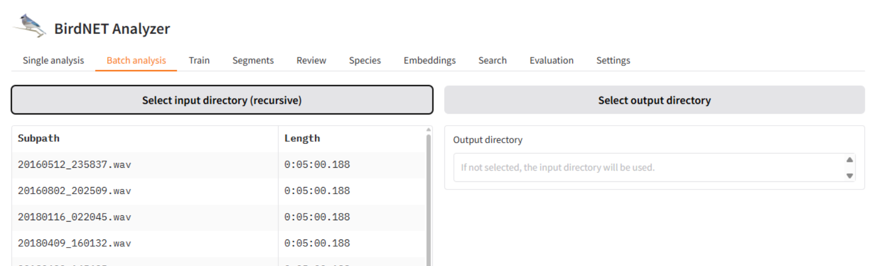
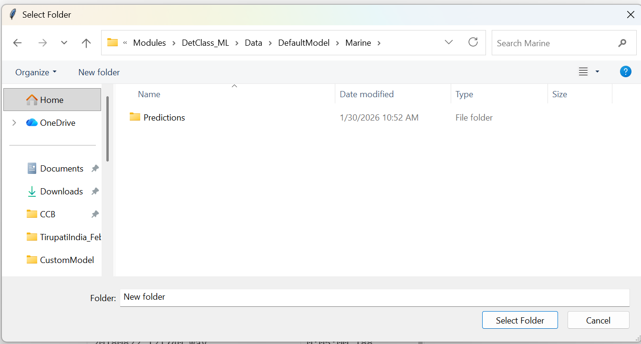

- Under Inference settings, set Maximum Bandpass Frequency (Hz) to 10000

- At the bottom of the screen, click Analyze. A progress bar will appear. When the analysis is complete it will switch to the message “All files analyzed!” Navigate to IISER_YC_AdvancedBioacoustics >> Modules >> DetClass_ML >> Data >> DefaultModel >> MarinePredictions to see the output selection tables.




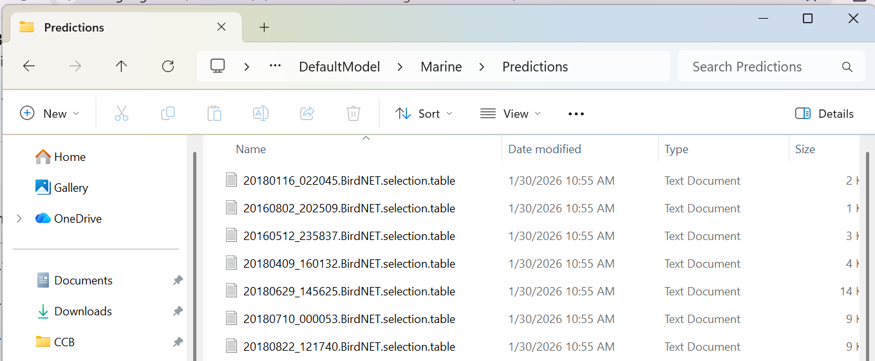

Part 3: Performance Evaluation

3.1 Viewing Annotations and Audio in Raven Annotate
- Launch Raven Annotate, Pro, or Lite. Select File → Open Sound Files. Navigate to IISER_YC_AdvancedBioacoustics >> Modules >> DetClass_ML >> Data >> Testing >> Audio Files >> Terrestrial and select the audio file 05_28_21_colorado_refuge_first5min.wav then click Open.
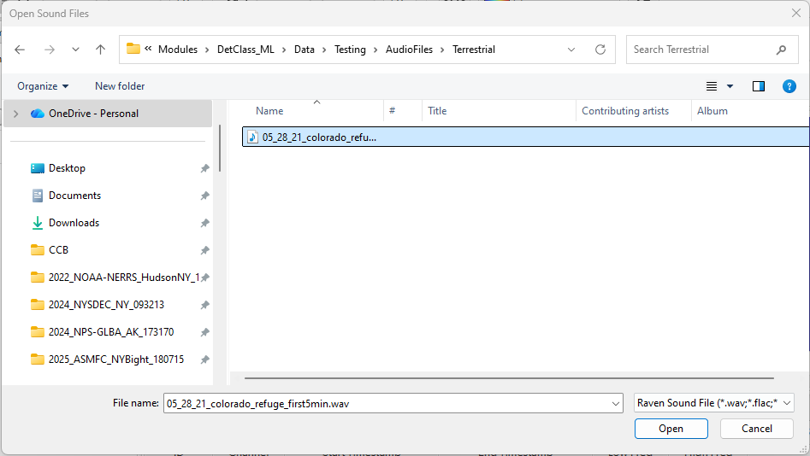
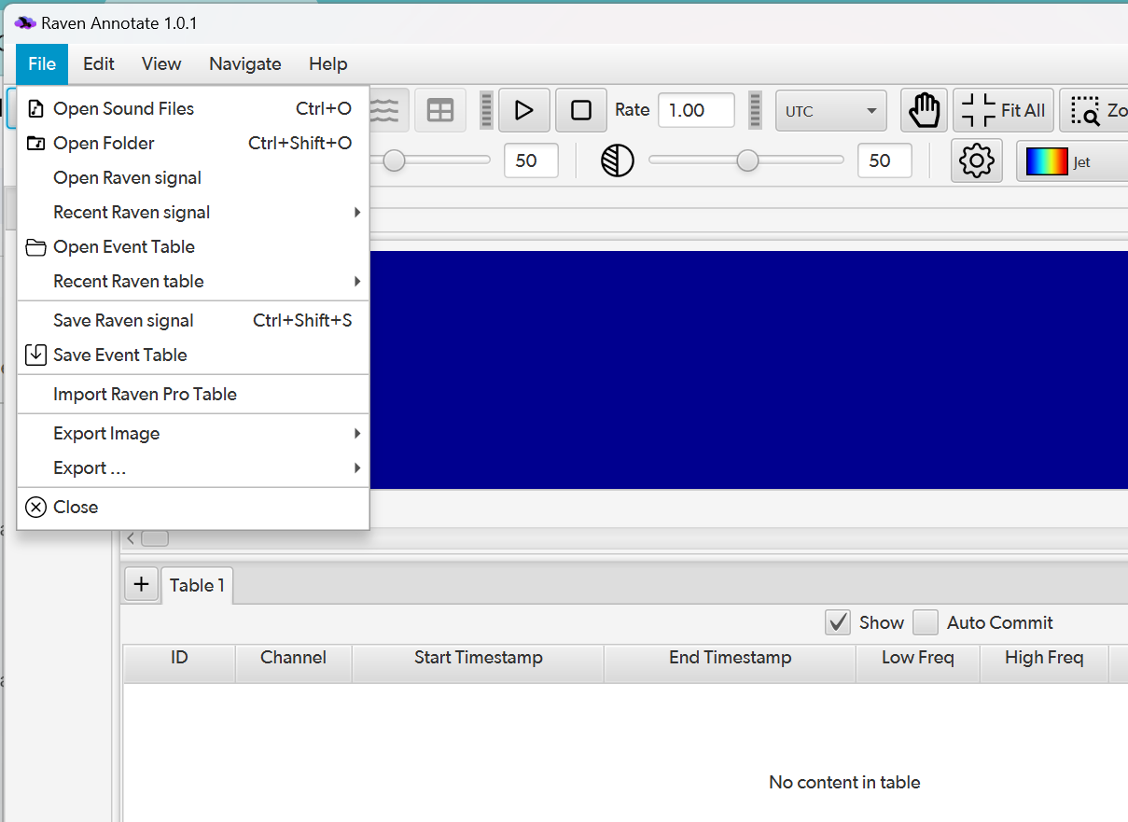

- A dialogue box will appear. Uncheck the box for “Use file timestamps for real time axis labels”. Click OK and the data will load.
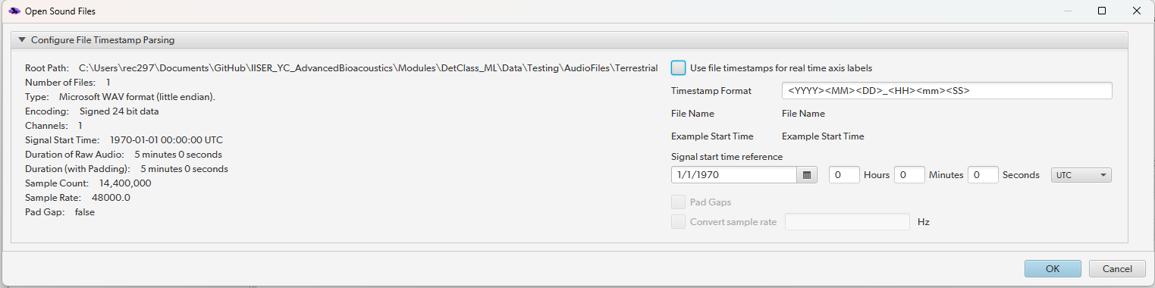

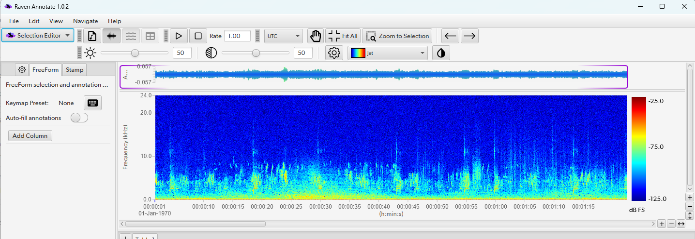
- Zoom in on the x-axis by clicking the + in the bottom right corner of the spectrogram panel. Use the x-axis scroll bar to navigate to the start of the file.

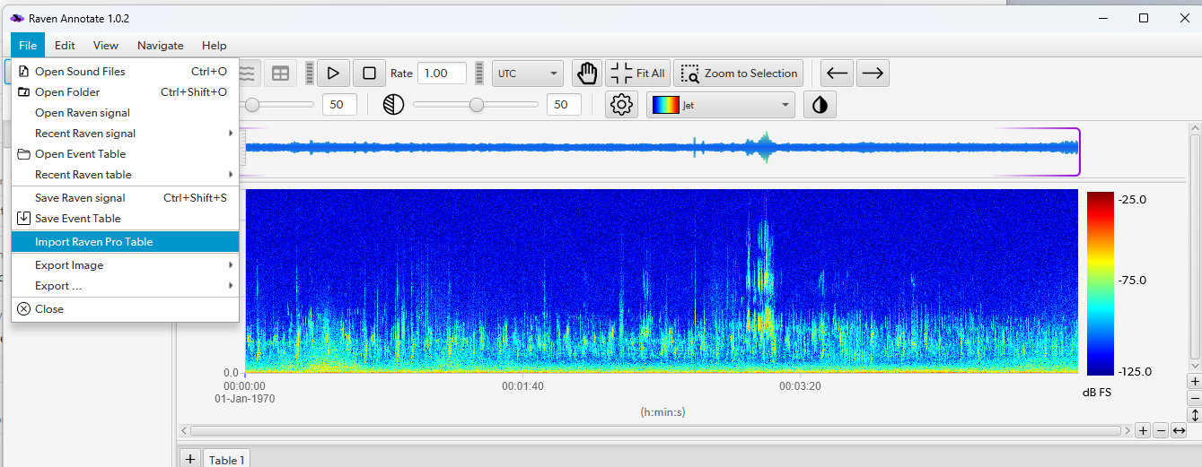
- Select File >> Import Raven Pro Table. Navigate to IISER_YC_AdvancedBioacoustics >> Modules >> DetClass_ML >> Data >> DefaultModel>> TerrestrialPredictions and select 5_28_21_colorado_refuge_first5min.BirdNET.selection.table.txt, then click Open.

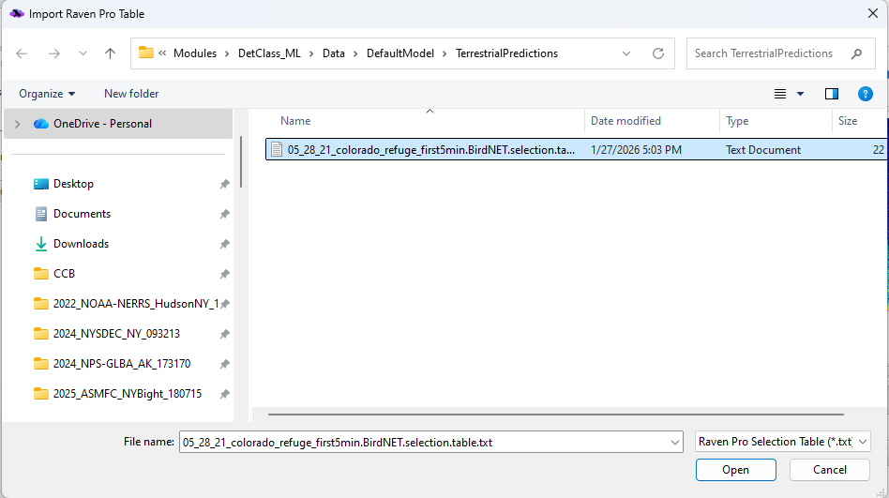

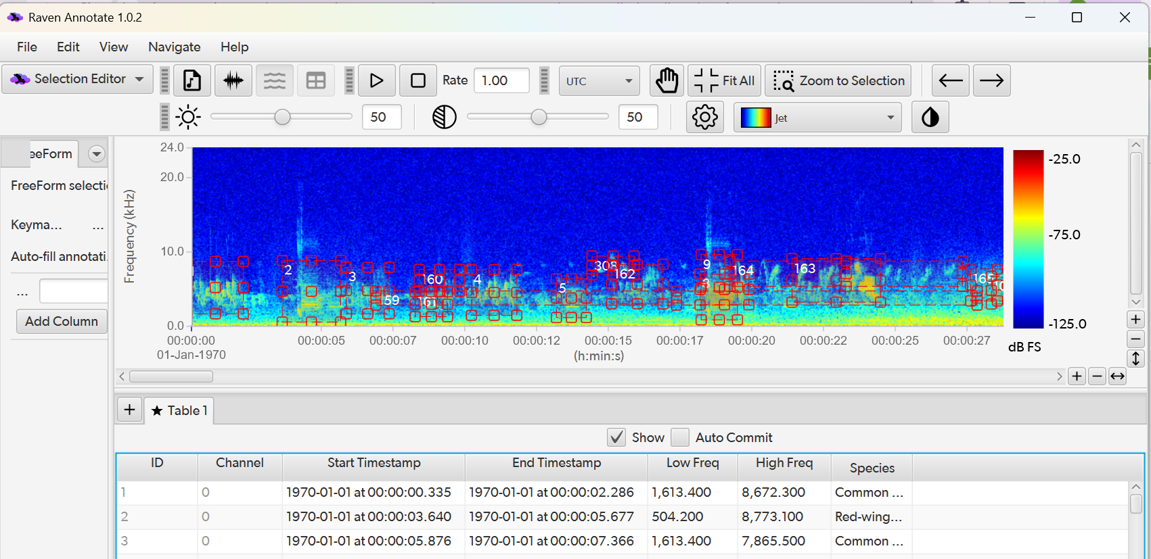

3.2 Quantifying Model Performance with BirdNET

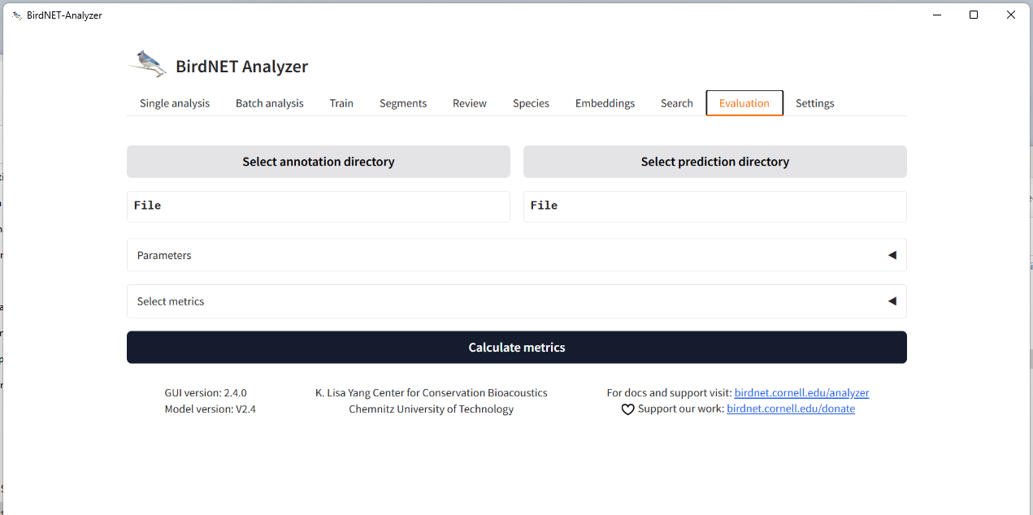
- Click on the Evaluation tab. Click Select annotation directory, navigate to IISER_YC_AdvancedBioacoustics >> Modules >> DetClass_ML >> Data >> Testing >> GroundTruthAnnotations>>Terrestrial, and click Select Folder.

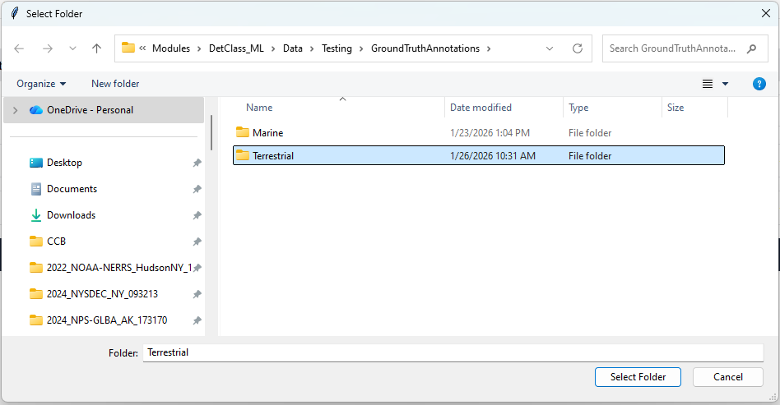

- Click Select prediction directory, navigate to IISER_YC_AdvancedBioacoustics >> Modules >> DetClass_ML >> Data >> DefaultModel >> Terrestrial >> Predictions, and click Select
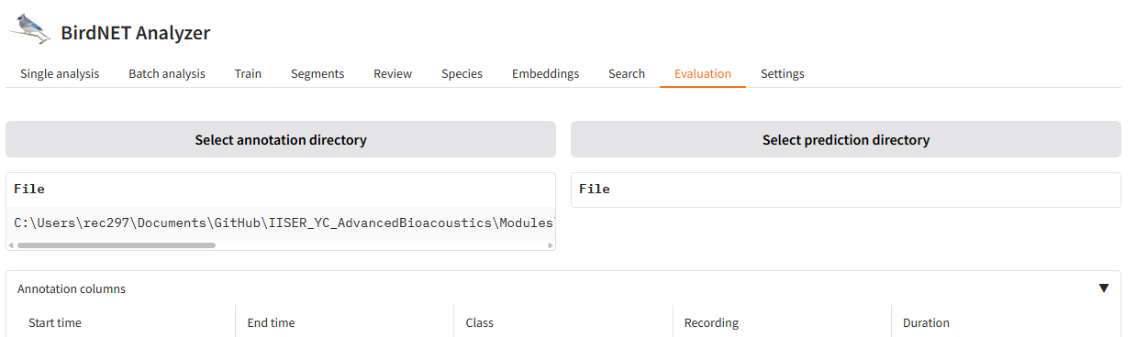
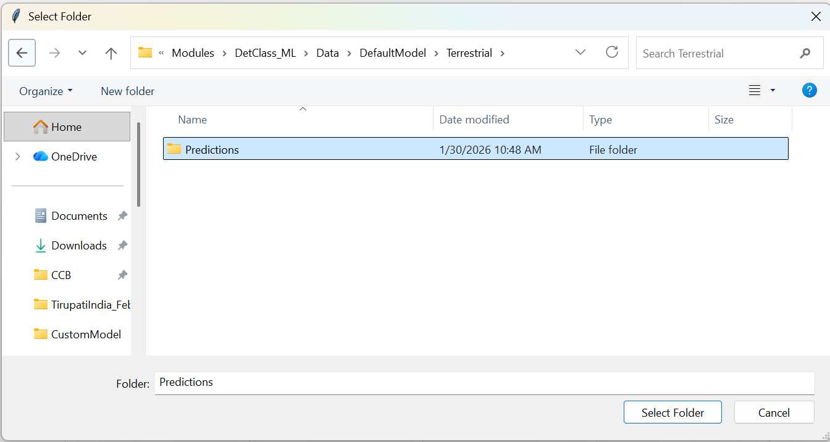

- Scroll down to Annotation columns. Under Class, use the drop down menu to select Species.
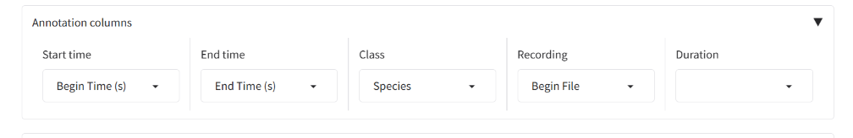

- Click Calculate metrics. A results table with precision and recall will be generated. Plot precision/recall/F1/accuracy vs. threshold by clicking Plot metrics for all thresholds.
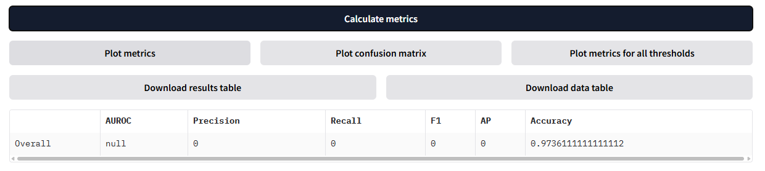

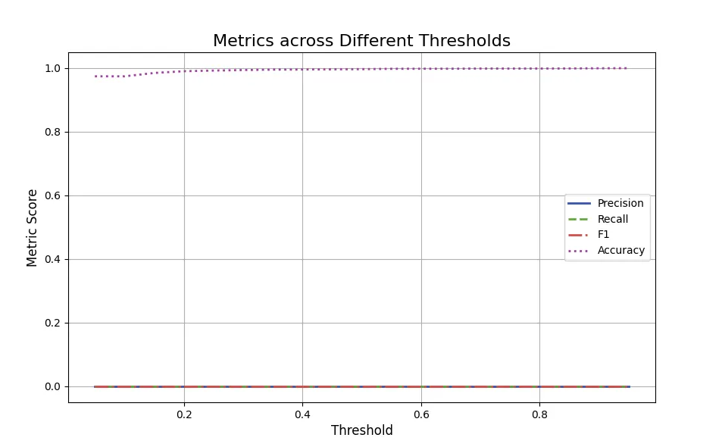

- Repeat process with marine ground truth (IISER_YC_AdvancedBioacoustics >> Modules >> DetClass_ML >> Data >> Testing >> GroundTruthAnnotations>>Marine) and marine BirdNET predictions (IISER_YC_AdvancedBioacoustics >> Modules >> DetClass_ML >> Data >> DefaultModel >> Marine >> Predictions).

3.3 Quantifying Model Performance with Custom Scripting
- Launch the workshop R Project by navigating to the downloaded GitHub repository folder IISER_YC_AdvancedBioacostics and double clicking the file IISER_YC_AdvancedBioacoustics.Rproj.
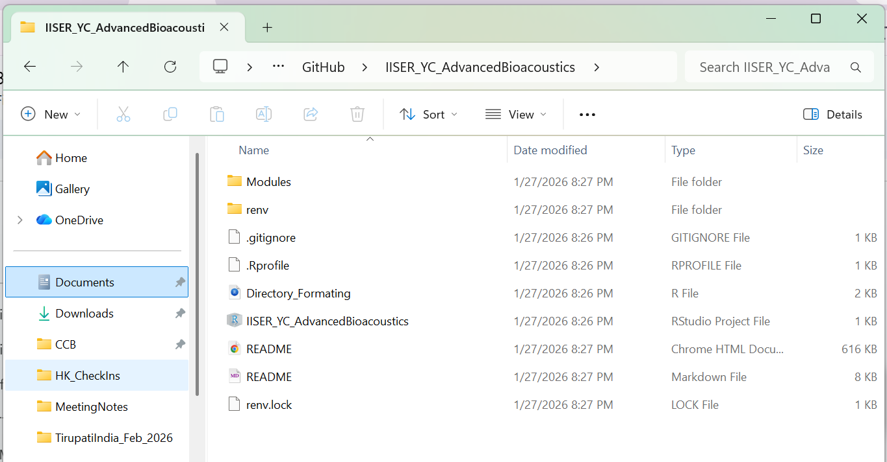

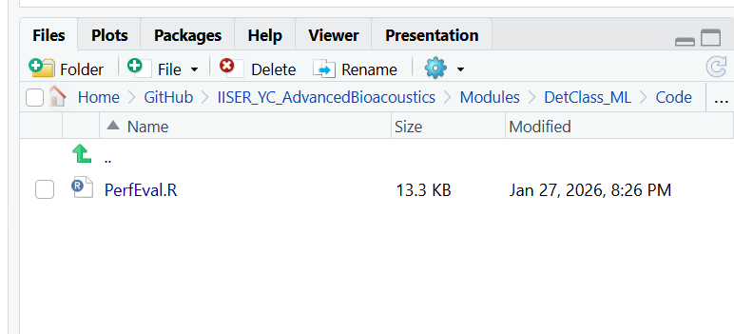
- In the Files pane of the RStudio session, navigate to IISER_YC_AdvancedBioacoustics >> Modules >> DetClass_ML >> Code and click PerfEval.R to open the script.

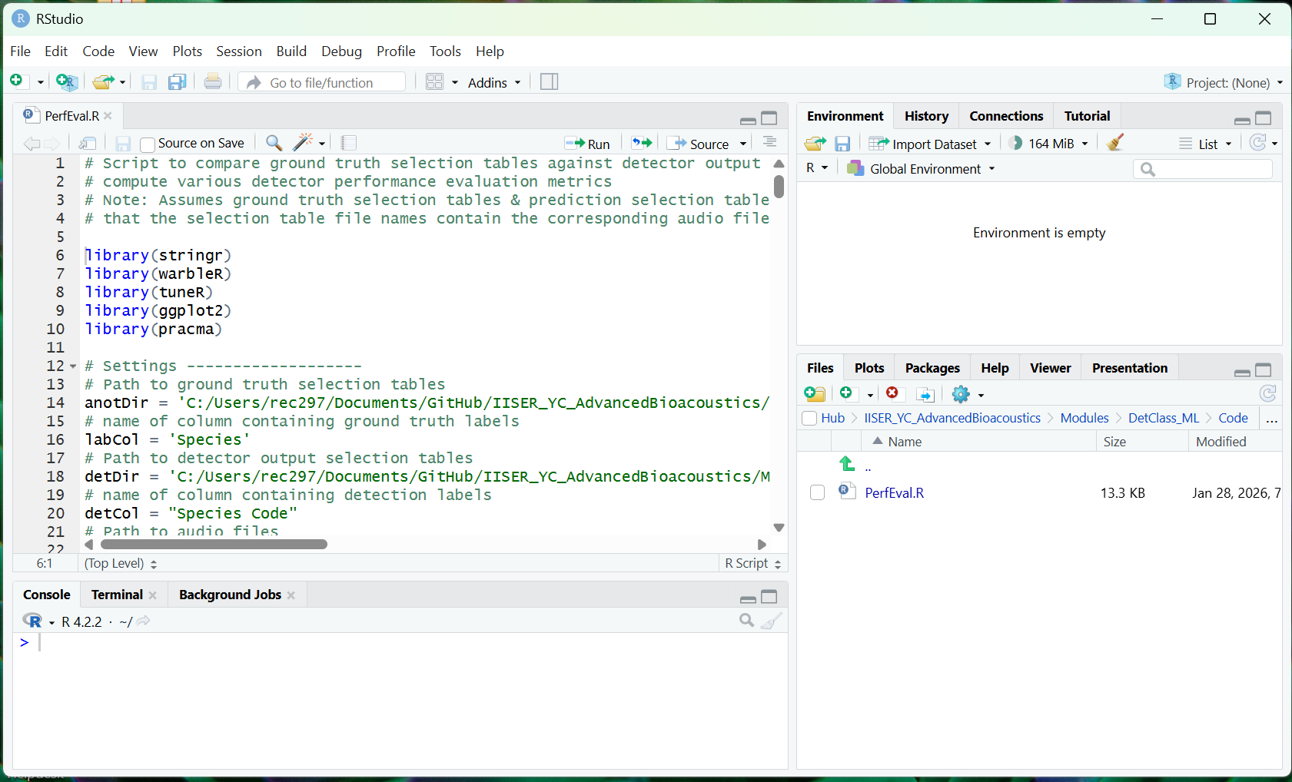

- Update the anotDir variable path in line 14 to IISER_YC_AdvancedBioacoustics >> Modules >> DetClass_ML >> Data >> Testing>> GroundTruthAnnotations >> Terrestrial
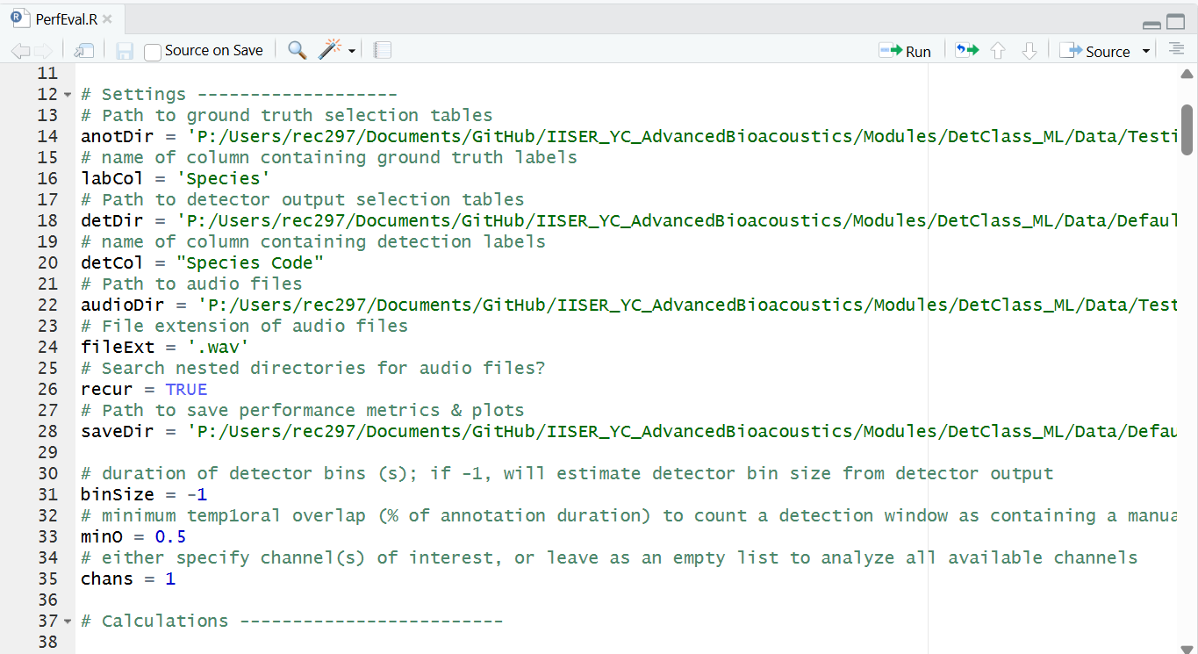

- Update the detDir variable path in line 18 to IISER_YC_AdvancedBioacoustics >> Modules >> DetClass_ML >> Data >> DefaultModel >> Terrestrial >> Predictions


- Update the detCol variable in line 20 to “Common Name”
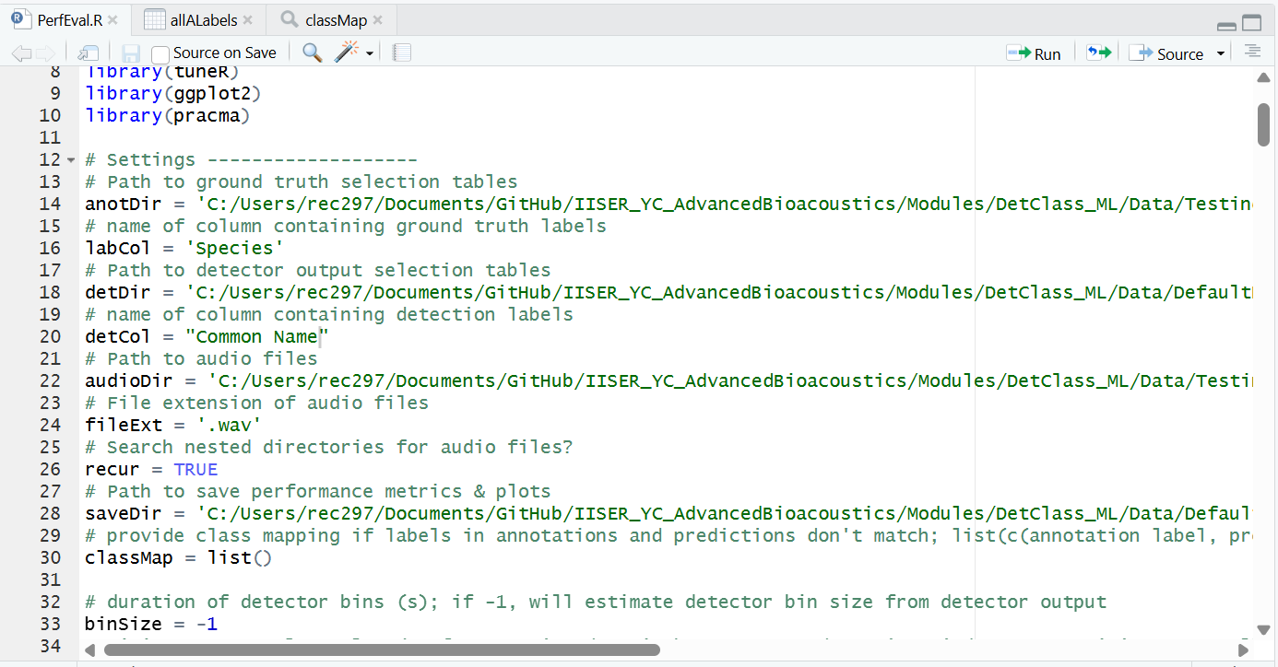

- Update the audioDir variable path in line 22 to IISER_YC_AdvancedBioacoustics >> Modules >> DetClass_ML >> Data >> Testing>> AudioFiles >> Terrestrial


- Update the saveDir variable path in line 28 to IISER_YC_AdvancedBioacoustics >> Modules >> DetClass_ML >> Data >> DefaultModel >> Terrestrial


- Run script by clicking Source button in upper right corner of script editor window
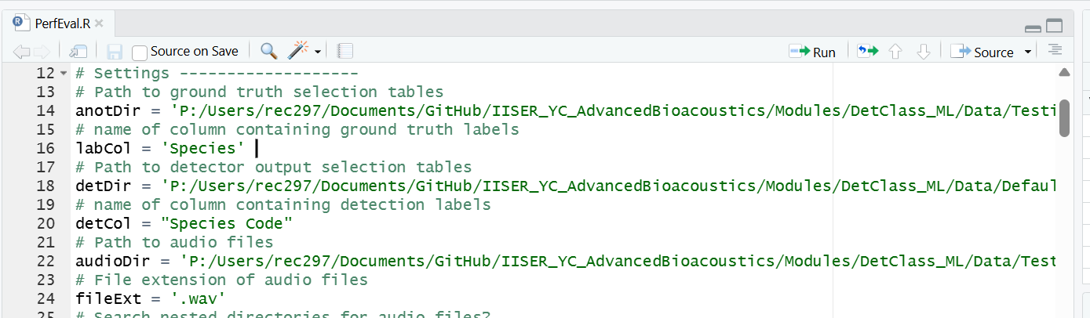

- In Windows Explorer or FInder, navigate to IISER_YC_AdvancedBioacoustics >> Modules >> DetClass_ML >> Data >> DefaultModel >> TerrestrialPredictions to view output figures.
- Repeat process for marine data predictions. Update the detCol variable in line 20 to “Species”

Part 4: Custom BirdNET Models
We can use BirdNET to detect sound classes that it was not originally trained on by applying transfer learning with a modest amount of training data. To train a custom BirdNET model, you need a training dataset consisting of short sound clips from both the target class(es) (specific species or sound type(s)) and at least one non-target class (e.g. background noise).

4.1 Training a Custom Model
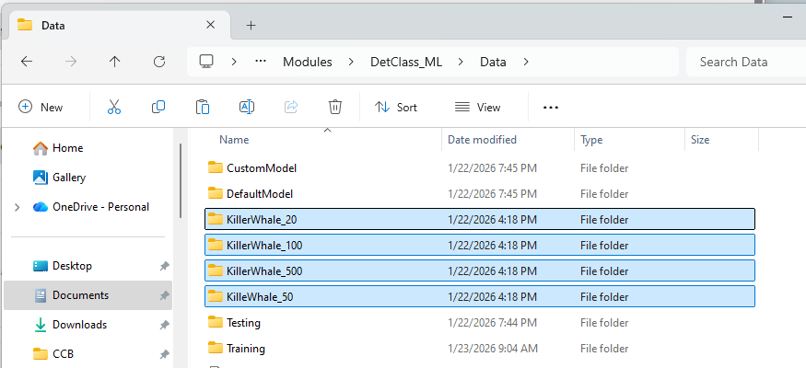
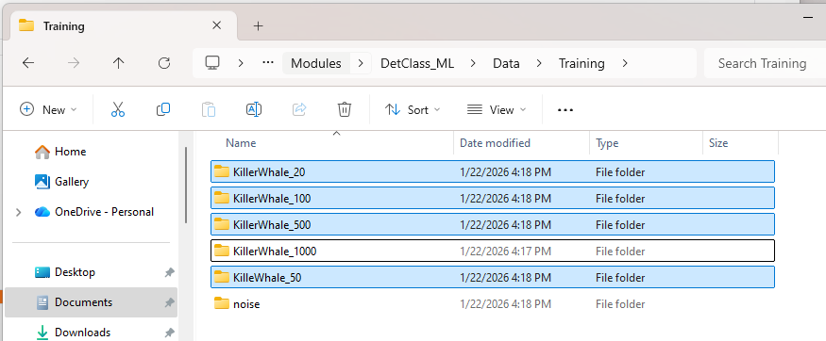

- We will train a custom model with two classes: Killer Whale and Noise. BirdNET will use all training data folders in the directory you point it towards, so we’ll need to reorganize the data slightly so that each team uses a different number of training examples. In the workshop folder, navigate to Modules >> DetClass_ML >> Data >> Training. Select and cut all killer whale training data folders except the one assigned to your group. Paste them up one level, directly into the Data folder.
Ctrl+V

Click
Select, Ctrl+X

- In BirdNET Analyzer, navigate to the Train tab. Click Select training data, navigate to Modules >> DetClass_ML >> Data >> Training, and click Select.
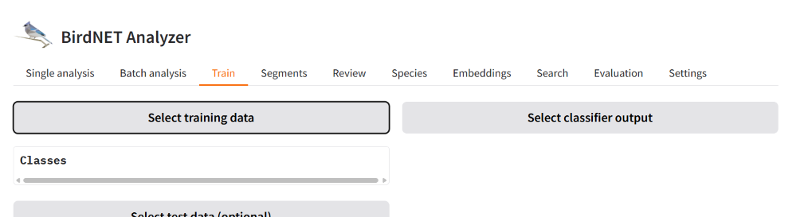
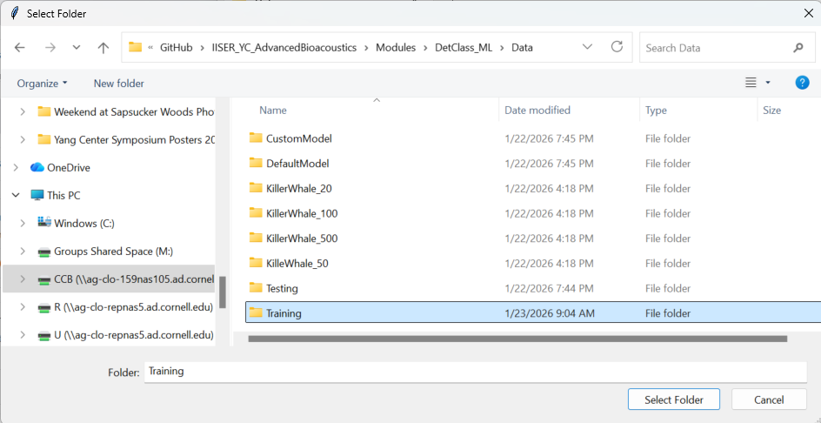

- Click Select classifier output, navigate to Modules >> DetClass_ML >> Data >> CustomModel, and click Select. You can also specify a name for your custom model (by default it will be called “CustomClassifier”).
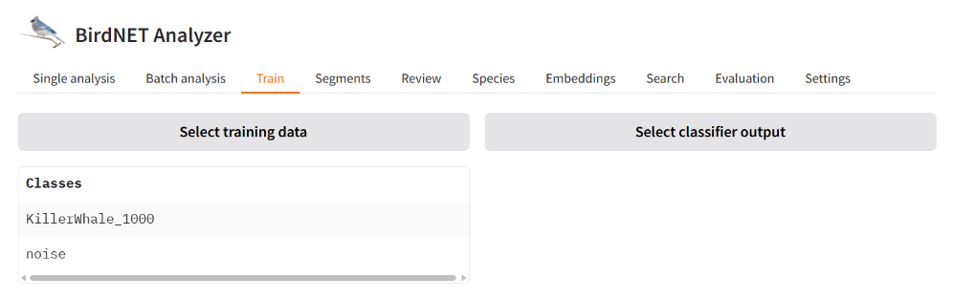

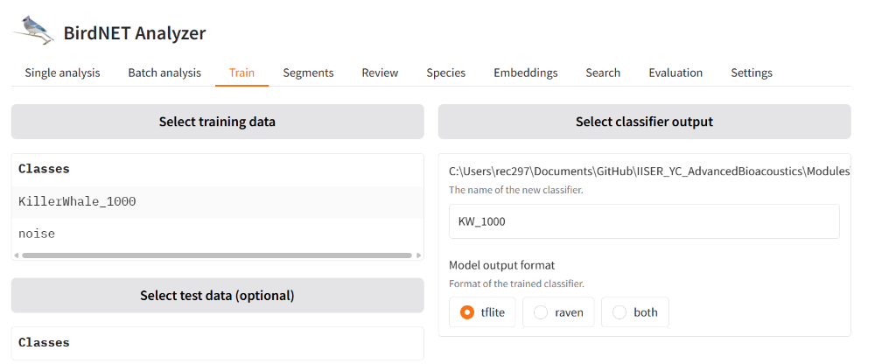
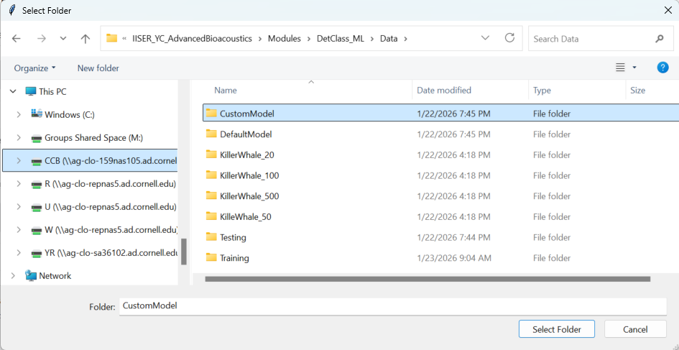

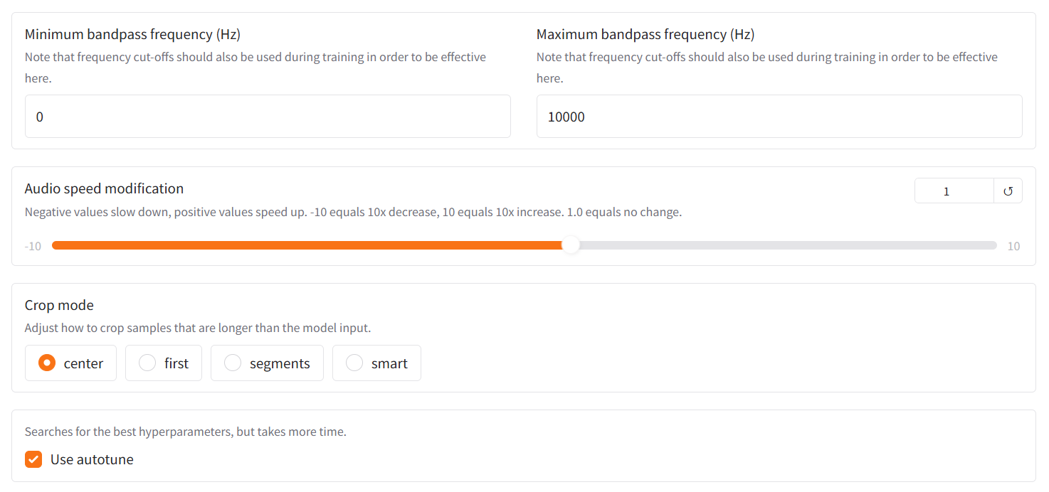
- Set the Maximum bandpass frequency (Hz) to 10000. Click the box next to Use autotune to implement automatic hyperparameter optimization.

- Scroll to the bottom of the train tab and click Start training.

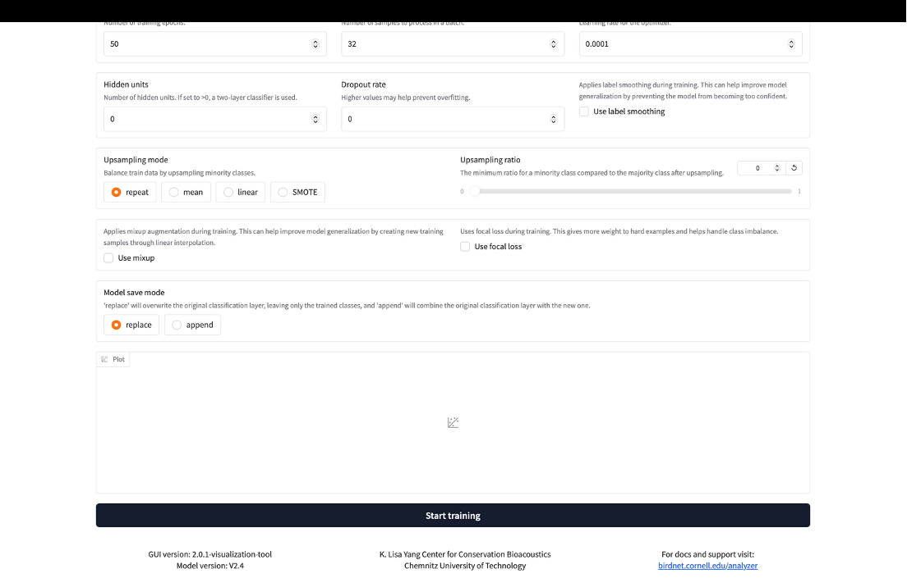

4.2 Deploying a Custom Model

- In the Batch analysis tab, click Select input directory and navigate to IISER_YC_AdvancedBioacoustics >> Modules >> DetClass_ML >> Data >> Testing >> Audio Files >> Marine.




- Click Select output directory and navigate to IISER_YC_AdvancedBioacoustics >> Modules >> DetClass_ML >> Data >> CustomModel, select Predictions, and click Select folder.

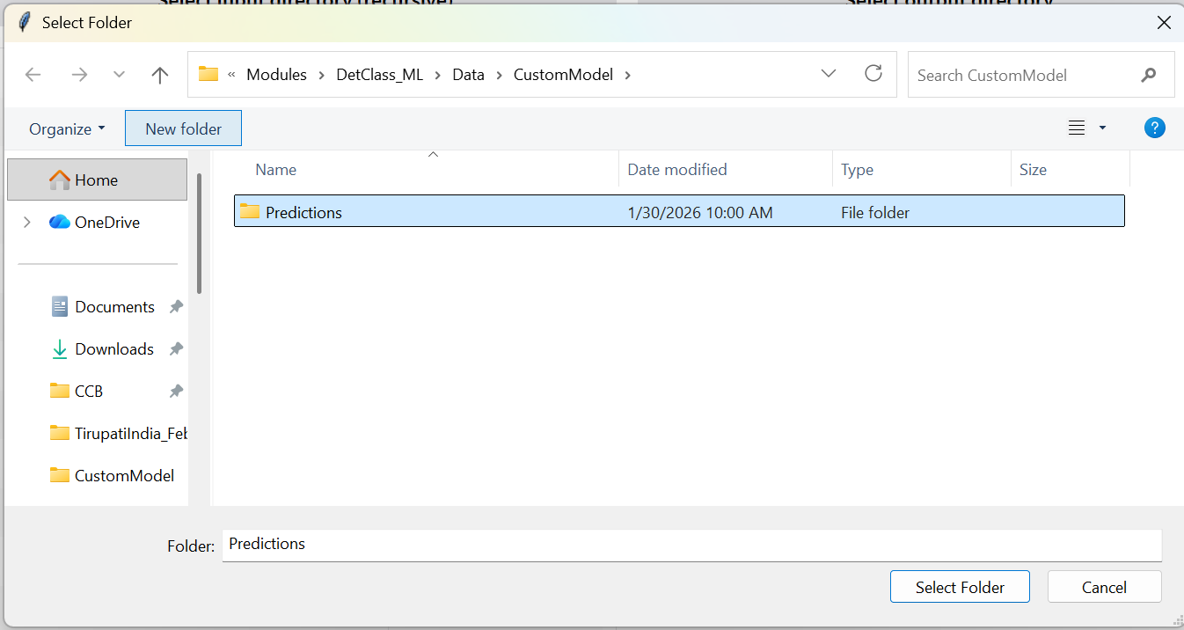

- Under Inference settings, set Maximum Bandpass Frequency (Hz) to 10000
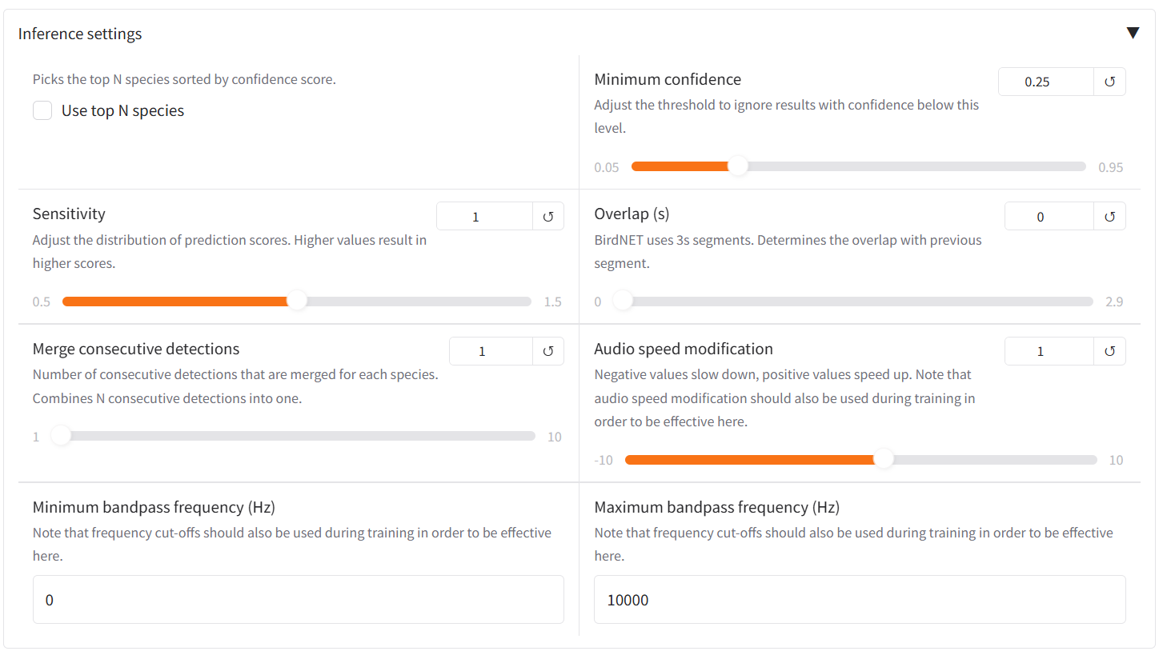

- Under Model selection, select Custom classifier, then click the Select classifier button and navigate to Modules >> DetClass_ML >> Data >> CustomModel, select the classifier you just trained and click Open.

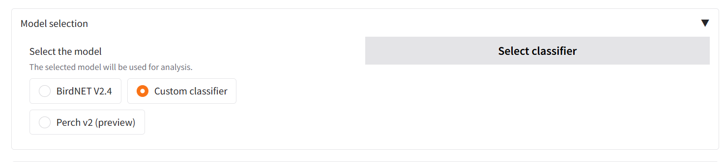

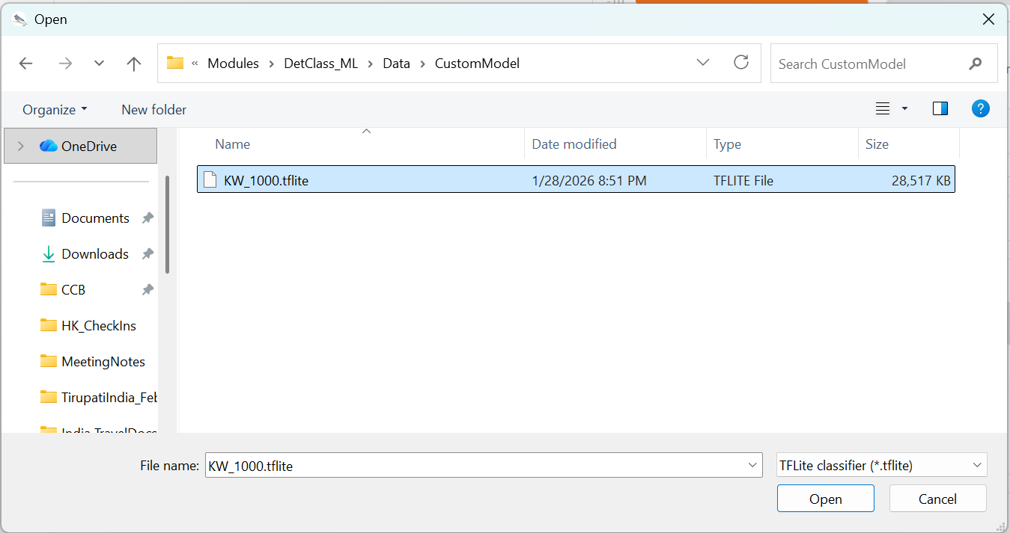

- Scroll to the bottom of the window and click Analyze to deploy the custom model.

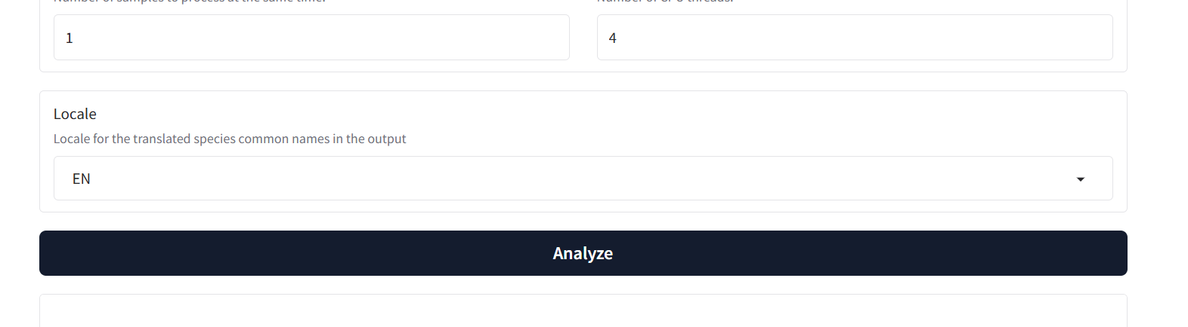

4.3 Evaluating Custom Model Performance
- Update the anotDir variable path in line 14 to IISER_YC_AdvancedBioacoustics >> Modules >> DetClass_ML >> Data >> Testing>> GroundTruthAnnotations >> Marine


- Update the detDir variable path in line 18 to IISER_YC_AdvancedBioacoustics >> Modules >> DetClass_ML >> Data >> CustomModel >> Predictions


- Update the audioDir variable path in line 22 to IISER_YC_AdvancedBioacoustics >> Modules >> DetClass_ML >> Data >> Testing>> AudioFiles >> Marine


- Update the saveDir variable path in line 28 to IISER_YC_AdvancedBioacoustics >> Modules >> DetClass_ML >> Data >> CustomModel


- Run script by clicking Source button in upper right corner of script editor window


- In Windows Explorer or FInder, navigate to IISER_YC_AdvancedBioacoustics >> Modules >> DetClass_ML >> Data >> CustomModel to view output figures.

